Final Project

Drew Whiteside

daw196@pitt.edu

INFSCI 1500

Dmitriy Babichenko

15 December 2021

Table of Contents

1. Title Page
2. Table of Contents
3. Introduction
4. ER Model
5. Business Rules
6. Entity/Attribute Descriptions
7. Entity/Attribute Descriptions (cont’d)
8. Entity/Attribute Descriptions (cont’d 2)
9. Questions for Queries
10. Closing

**Introduction**

I will be creating a database that keeps track of concerts, the artists who performed at them, the venues they were performed at, and many more music-related elements. In total, I will illustrate relationships between venues, organizers, concerts, songs, tours, artists, managers, albums, writers, and labels.

The target audience would be music enthusiasts who are interested in what types of songs have been played at concerts by their favorite artists. The purpose of my database is to create a simple way to look up details about the concerts played by a particular artist, which can then be filtered by a multitude of details such as location and who organized the events.

**ER Model**

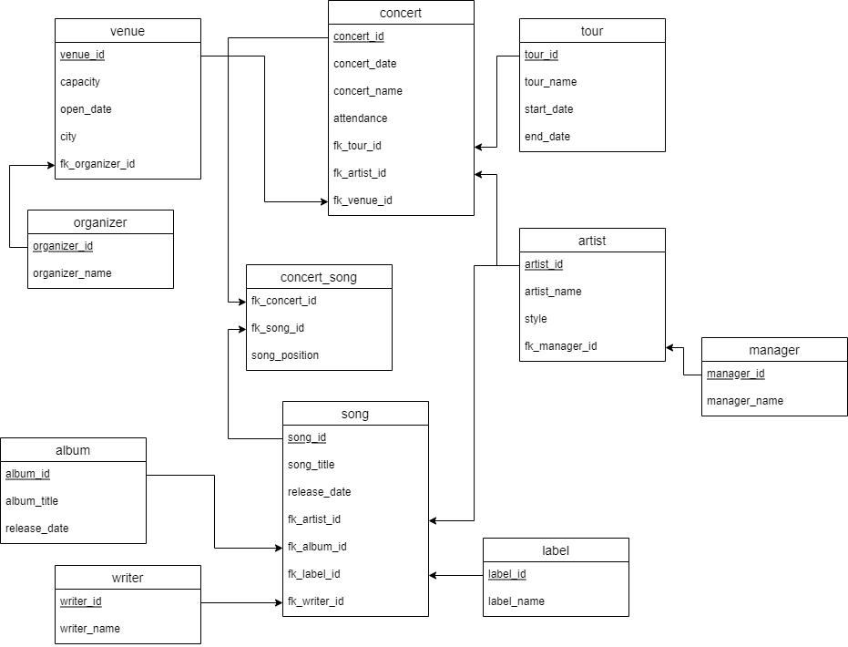

**Business Rules**

|  |  |  |  |  |
| --- | --- | --- | --- | --- |
| **Entity 1** | **Entity 2** | **Cardinality on Entity 1 Side** | **Cardinality on Entity 2 Side** | **Business Rules** |
| organizer | venue | 1 | 1.. * | An organizer can be in charge of many venues, but a venue is only run by 1 organizer. |
| venue | concert | 1 | 1.. * | A venue can host many concerts, but a concert is held at one specific venue. |
| concert | song | 1.. * | 1.. * | A concert includes many songs, and a song can be played at many concerts. |
| tour | concert | 1 | 1.. * | A tour can include many concerts, while a concert can only be part of 1 tour. |
| artist | concert | 1 | 1.. * | An artist can perform at many concerts, but a concert is only performed buy 1 artist. |
| manager | artist | 1 | 1.. * | A manager can manage many artists, but an artist is only managed by 1 manager. |
| label | song | 1 | 1.. * | A label can have many songs signed under it, while a song is only signed under 1 label. |
| writer | song | 1 | 1.. * | A writer can write multiple songs, while a song is only written by 1 writer. |
| album | song | 1 | 1.. * | An album includes many songs, while a song is only assigned to 1 album. |

**Entity/Attribute Descriptions**

|  |  |  |
| --- | --- | --- |
| **organizer** | | |
| organizer_id | INT | Primary key for the id of the organizer |
| organizer_name | VARCHAR(200) | Name of the organizer for a venue |

|  |  |  |
| --- | --- | --- |
| **venue** | | |
| venue_id | INT | Primary key for the id of the venues |
| capacity | INT | Capacity of the venue |
| open_date | DATETIME | Date the venue was opened |
| city | VARCHAR(200) | City the venue is located in |
| fk_organizer_id | INT | Foreign key referencing the ‘organizer’ table |

|  |  |  |
| --- | --- | --- |
| **Concert** | | |
| concert_id | INT | Primary key for the id of the concert |
| concert_name | VARCHAR(200) | Name of the concert |
| concert_date | DATETIME | Date of the concert |
| attendance | INT | How many people attended |
| fk_tour_id | INT | Foreign key referencing the ‘tour’ table |
| fk_artist_id | INT | Foreign key referencing the ‘artist’ table |
| fk_venue_id | INT | Foreign key referencing the ‘venue’ table |

|  |  |  |
| --- | --- | --- |
| **Song** | | |
| song_id | INT | Primary key for the id of the song |
| song_title | VARCHAR(200) | Title of the song |
| release_date | DATETIME | Date the song was relesed |
| artist_id | INT | Foreign key referencing the ‘artist’ table |
| album_id | INT | Foreign key referencing the ‘album’ table |
| label_id | INT | Foreign key referencing the ‘lable’ table |
| writer_id | INT | Foreign key referencing the ‘writer’ table |

|  |  |  |
| --- | --- | --- |
| **concert_song** | | |
| concert_id | INT | Foreign key referencing the ‘concert’ table |
| song_id | INT | Foreign key referencing the ‘song’ table |
| song_position | INT | Position the song was played in the show relative to the other songs |

|  |  |  |
| --- | --- | --- |
| **Album** | | |
| album_id | INT | Primary key for the id of the album |
| album_title | VARCHAR(200) | Title of the album |
| release_date | DATETIME | Date the album was released |

|  |  |  |
| --- | --- | --- |
| **Writer** | | |
| writer_id | INT | Primary key for the id of the writer |
| writer_name | VARCHAR(200) | Name of the writer |

|  |  |  |
| --- | --- | --- |
| **Label** | | |
| label_id | INT | Primary key for the label a song was released under |
| label_name | VARCHAR(200) | Name of the label |

|  |  |  |
| --- | --- | --- |
| **Tour** | | |
| tour_id | INT | Primary key for the id of the tour |
| tour_name | VARCHAR(200) | Name of the tour |
| start_date | DATETIME | Date the tour began |
| end_date | DATETIME | Date the tour ended |

|  |  |  |
| --- | --- | --- |
| **Artist** |  |  |
| artist_id | INT | Primary key for the id of the artist |
| artist_name | VARCHAR(200) | Name of the artist |
| style | VARCHAR(200) | Music style of the artist |
| fk_manager_id | INT | Foreign key referencing the ‘manager’ table |

|  |  |  |
| --- | --- | --- |
| **Manager** | | |
| manager_id | INT | Primary key for the id of the manager |
| manager_name | VARCHAR(200) | Name of the manager |

**Questions for Queries**

|  |  |
| --- | --- |
| Question to answer | How answer adds value |
| Which concerts include songs that were released before January 1st, 2016? | Allows user to sort concerts based on when songs played at that concert were originally released |
| What is the average attendance of the concerts performed by artist Madeon? | Allows user to see average attendance of all the concerts played by a certain artist |
| What are all the concerts listed in order by date? | Allows user to see a chronological list of concerts |
| What were all of the concerts that occured in either Pittsburgh or Wheeling? | Allowers user to filter concerts based on what city they occurred in |
| What were the first 3 songs written by Daniel Adams-Ray in order of release? | Allows user to see a chronological list of songs written by a certain writer |
| Which concerts include songs that were released under Orange Records? | Allows user to filter concerts based on the labels by which the played songs were released under |
| Which concerts were performed by EDM artists after 2018? | Allows user to filter concerts based on the style of artist and also in a certain time period |
| What is the total attendance of all concerts organized by Comix in the city of Pittsburgh? | Allows summation of attendance based on concerts with a certain organizer and a certain location |
| What were the 3 most recent concerts that were part of the Nurture Live tour? | Allows viewing of chronological concerts in a specific tour and also a limit to the amount of returned results |
| How many times has the artist Avicii played a song from the album 'True' at a concert? | Allows the summation of how many times a certain artist has played songs from a certain album |

**Conclusion**

This project was time consuming yet fulfilling. The most difficult part was the entering of data, which took effort not only to come up with relevant data points, but also to enter each individual data point. The easiest part was the creation of the business rules because after I had the ER diagram in place, it was easy to translate that logic into that table. Overall, throughout this project, I learned a lot about how SQL queries operate and how they can be utilized for specific results.